

|  |  |  |
| --- | --- | --- |
| **Name:** | **SRN:** | **Section:** |
| **Date:** | **Unit 1 Assignment**  **Exercise** |

PROBLEM STATEMENT1 (for EVEN number SRNs):

Create an Indian Budget 2024 survey form template using HTML tags headings, paragraphs, anchor tags, tables, images, forms and lists.

This **HTML template** should include:

* **Heading** “**Indian Budget 2024 Survey Form”.**
* An **overview of the budget highlights** in a **table** with the **table heading “Indian Budget 2024 Highlights”Form** consisting of **multiple fields** and a **list of schemes announced in the 2024 budget by the Finance Minister.**
  1. **A link to display more detailed information on the budget.**
  2. **Background color** to the **table and page**.
  3. **Row span and column span wherever needed**.
  4. Use **external CSS** for **styling the webpage**.
  5. **Basic JavaScript function** to handle the feedback **form submission.**

The **web page** should display

1. **Form** consisting of **multiple fields which should include**
   1. **Textboxes**
   2. **Labels**
   3. **Radio buttons**
   4. **Dropdowns**
2. Use **external CSS** for **styling the webpage.**



1. **Add relevant images to the page,** including **at least one compulsory image**.
2. A **feedback form** to collect the **user's name, Gender, email, phone number, State and feedback.**
3. **Validate the form fields** using **input properties**
   1. **All the fields** in the form are **required.**
   2. **Email** should be in **proper format**
   3. **Mobile number** field should consist of **exactly 10 digits**
   4. **Reset button** to be there to **reset all the fields**.
   5. **Set the default state to one option**, and provide a dropdown menu to select other states or choose 'Other’.
   6. **Feedback** should be **entered before submitting the form.**
4. Make use of a **function for on submit button click**, using **JavaScript** to display ***“Thank you for your feedback, <user’s name>!”*** *as an* **alert message.**
5. Use the **reset button** to **clear all fields**.



|  |
| --- |
| **OBJECTIVE**  The objective of this exercise is to test the student on HTML. It evaluates the student’s knowledge on the basic HTML tags for displaying images, lists, tables, forms and links, CSS Styles and JavaScript Basics.  **PREREQUISITE**  In order to complete this exercise, the student needs to understand the fundamentals of HTML and CSS. The student must be familiar with the basic HTML tags for creating links, lists etc., CSS and JavaScript.  **PROGRAM** |
| **SCREENSHOT OF YOUR OUTPUT** |
|  |



**SCREENSHOT OF OUTPUT (***reference)*

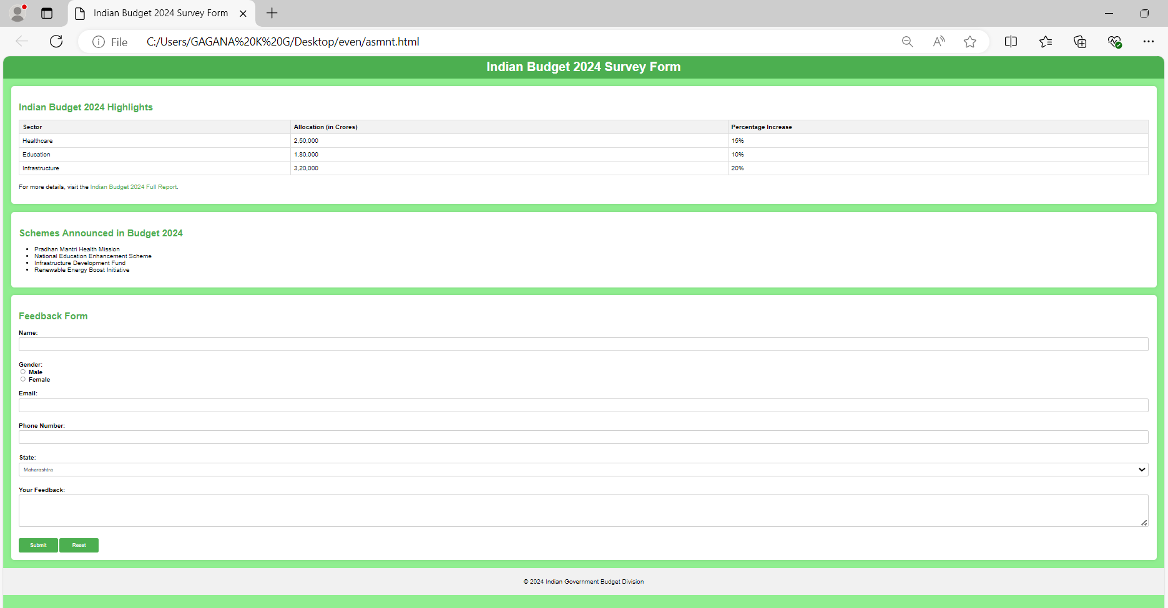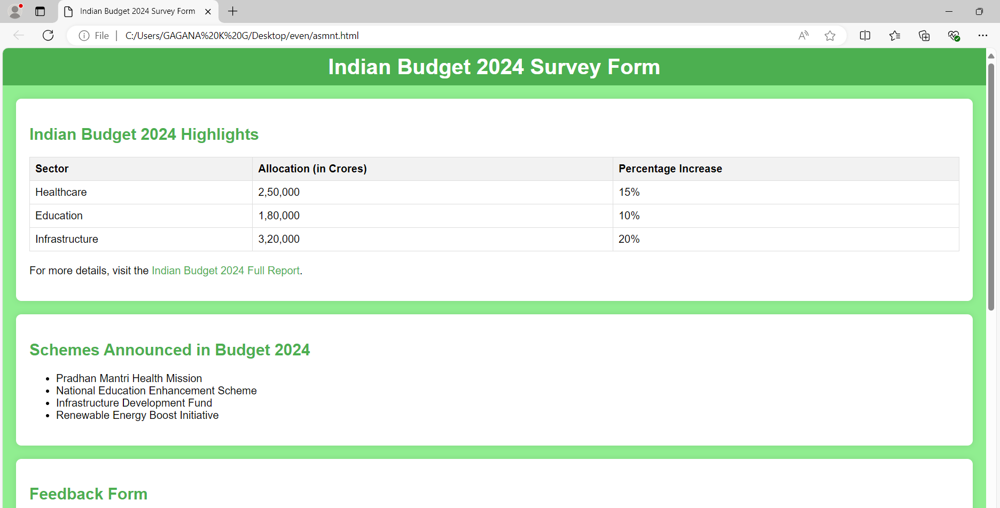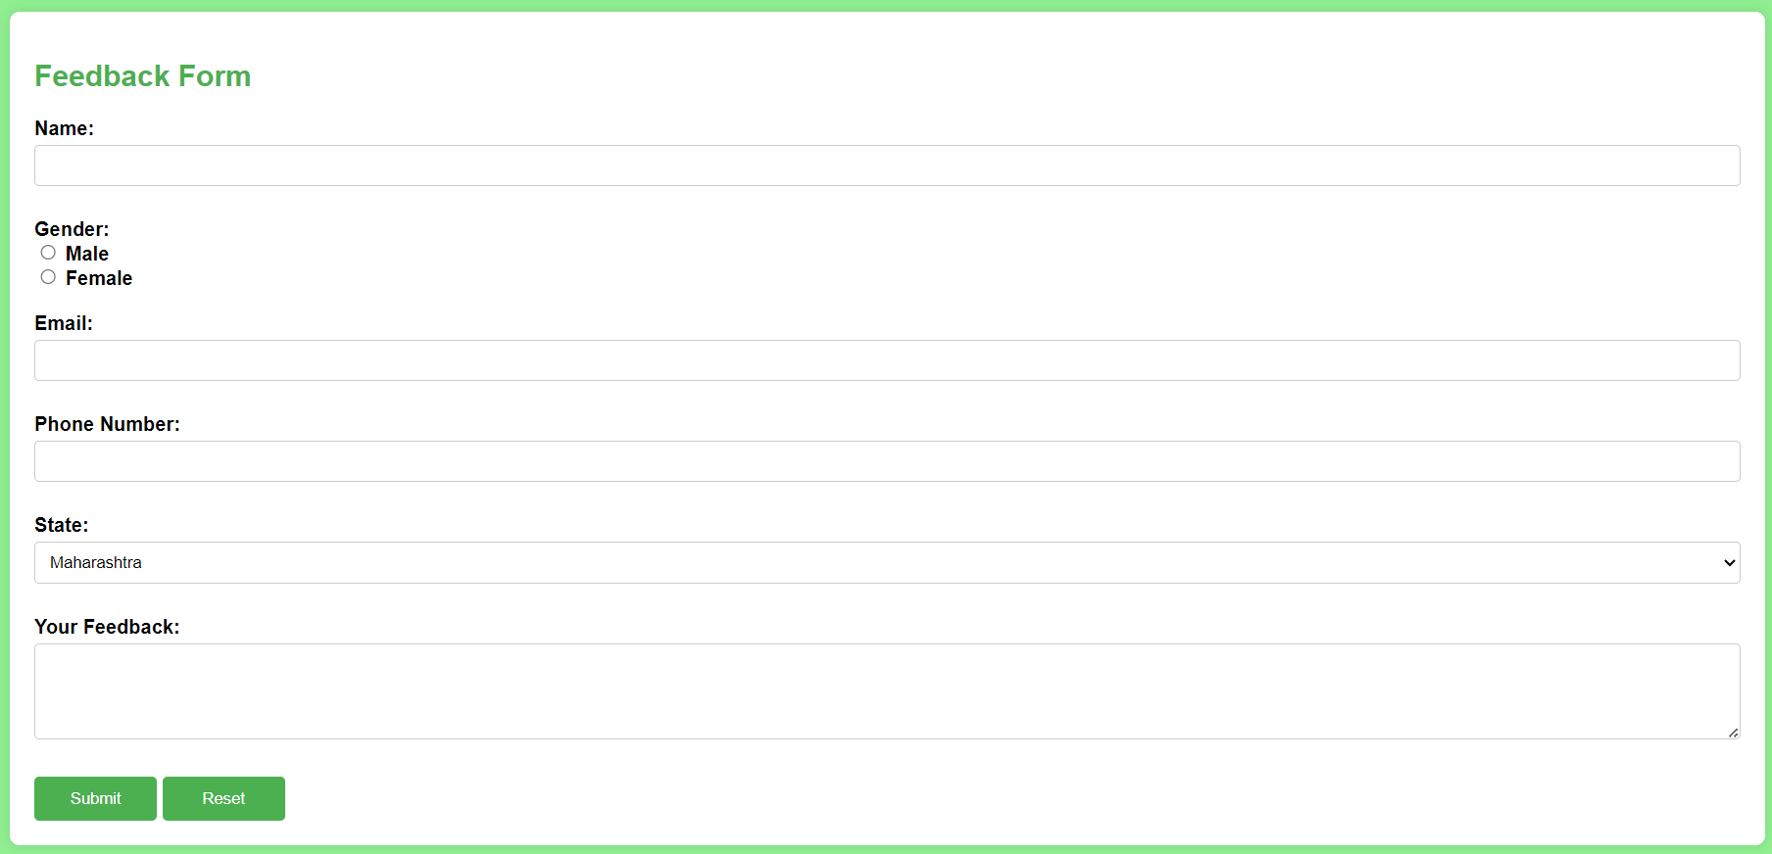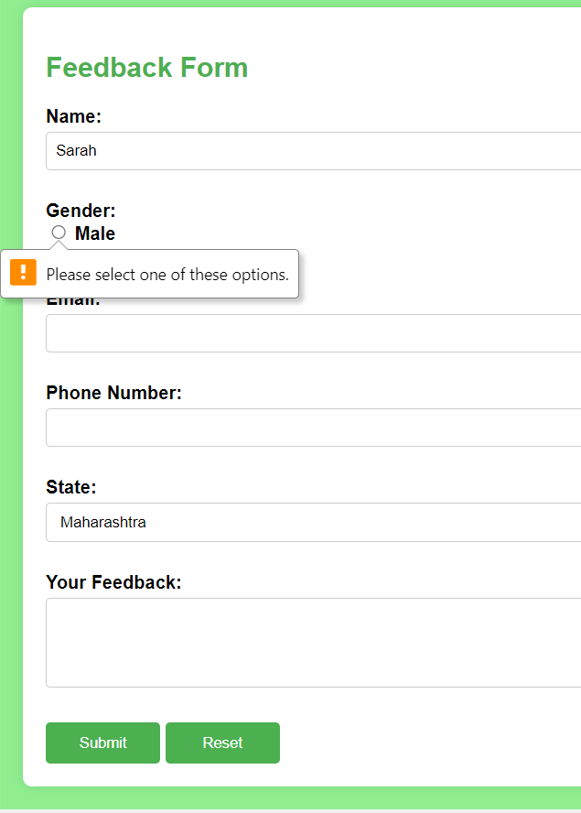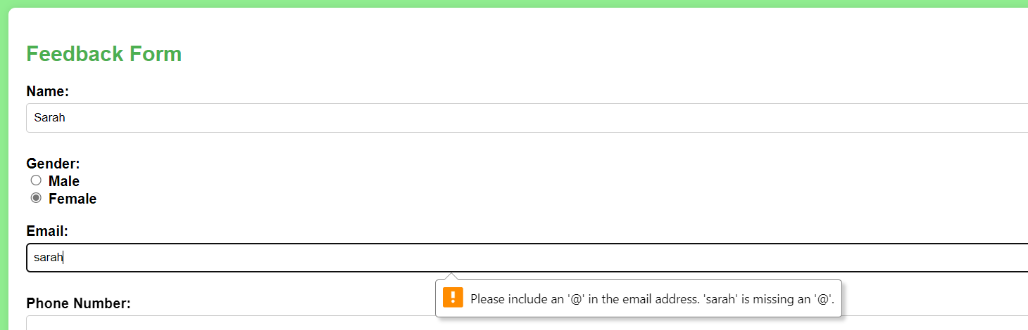

->

**PES Unit 1: HTML, CSS AND CLIE.NT-S.I.DESCRIPTING**

**UNIVERSITY**

**AUG-DEC**

**2024**

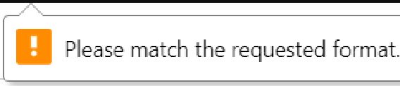

**Phone Number:**

**State:**

**State:**

Malharashtra

Maharashtra Gujarat Karnataka Tamil Nadu Other

**Feedback Form**

**Name:**

Sarah

**Gender:**

0 Male

@ **Female**

Email:

[sarah@gmail.com](mailto:sarah@gmail.com)

**Phone Number:**

1234567891

State:

Maharashtra

**Your Feedback:**

* **iiEEi#E** II Please fill out this field



